**The Evolution of Dedicated Cycling Infrastructure in Three Canadian Cities from 2009 to 2022**

Konrad Samsel1,2, Richard Wen1,2, Brice Batomen1, Andrew Howard,3 Meghan Winters4, Moreno Zanotto4, Brent Hagel,5Colin Macarthur3, Linda Rothman1,2

Affiliations:

1. Dalla Lana School of Public Health, University of Toronto, 155 College Street, Toronto ON M5T 3M7
2. School of Occupational and Public Health, Toronto Metropolitan University, 350 Victoria Street, Toronto ON M5B 2K3
3. Child Health Evaluative Sciences, SickKids Research Institute, 686 Bay St, Toronto, ON, Canada M5G 0A4
4. Faculty of Health Sciences, Simon Fraser University, 8888 University Drive, Burnaby, BC, Canada, V5A 1S6
5. Departments of Pediatrics and Community Health Sciences, Cumming School of Medicine, University of Calgary, C4-434, Alberta Children’s Hospital, 28 Oki Drive NW, Calgary, AB, Canada, T3B 6A8

**Address Correspondence to: Richard Wen**

Department of Public Health Sciences,

University of Toronto,

155 College Street,

Toronto ON M5T 3M7

(richard.wen@utoronto.ca)

**ABSTRACT**

**Introduction**

Municipalities often prioritize cycling within urban centers, given that cycling is a cost-effective means of transportation, and promotes healthy living. Despite considerable investments in cycling infrastructure, however, challenges related to safe and equitable cycling access persist. This project examined the implementation of safe cycling infrastructure in three major cities in Canada - Vancouver, Calgary, and Toronto – over the time period 2009 to 2022.

**Methods**

The study focused on on-street infrastructure that was designated for the exclusive use by cyclists, which were painted lanes, buffered lanes, cycle track and local street bikeways. Information on current infrastructure was acquired in January 2023 from each municipality. Instances of new installations and upgrades occurring between 2009 and 2022 were assessed and verified using a combination of municipal data sources, grey literature, and historical street view imagery. A standardized criterion, drawn from The Canadian Bikeway Comfort and Safety (Can-BICS) classification system, allowed for consistent classification of infrastructure, enabling comparison of infrastructure implementation across municipalities and over time.

**Results**

From 2009 to 2022, there was a three-fold increase in dedicated on-street cycling infrastructure in Vancouver (XX to XX km) and Toronto (XXX to XXX km), and an eleven-fold increase in Calgary(xx to xx). A key finding was the marked acceleration of cycling infrastructure in Calgary and Toronto from the onset of the COVID-19 pandemic. The highest annual rate of cycling infrastructure installations for both cities occurred during this time (1 km - 6 km of new infrastructure per 1000 centerline-km of roadway).

**Conclusion**

All three cities showed a expansion of dedicated cycling infrastructure from 2009-2022, reflecting a conscious urban planning shift towards safer and more secure cycling infrastructure. The public health response to the COVID-19 pandemic accelerated cycling infrastructure development across all cities.

**INTRODUCTION**

Recognizing the significance of sustainable mobility, Canadian municipalities are intensifying efforts to enhance active transportation infrastructure, for mobility, environmental, and health impacts (1). (2). This approach has the potential to alleviate transportation demands and align with broader environmental targets (3,4). Consequently, many large Canadian cities have made considerable progress in building new bikeways and upgrading infrastructure to create active spaces for individuals of all ages and abilities (5).

The challenge of road safety persists as a pressing public health concern with an immense human and economic burden (9). For example, in Toronto, Ontario, 858 cyclists suffered injuries (812 major and 46 fatal injuries, respectively) between 2006 to 2023 (10), which associated direct and indirect economic costs of more than $60 million per year (11). Across Canada, the costs of cycling injuries in 2018 was 377 million CAD (12). In addition to public health impacts, the perceived risk of injury associated with on-street cycling may also deter its adoption as an alternative transportation option (2). Aligned with urban planning initiatives, the Vision Zero road safety strategy, launched in Sweden in 1997 and now adopted in cities globally, stands as a crucial guiding principle for road safety Vision Zero strives to eliminate all severe and fatal road transportation injuries while promoting healthy and equitable mobility for all. Unlike traditional approaches that place burdens of safety on road users, Vision Zero acknowledges human error and focuses on road system designs to prevent traffic deaths (6–8).

There are equity issues related to safe cycling, including access to safe cycling infrastructure and collision risk in more marginalized areas, as well as those related to demographic characteristics in terms of age, sex, ability. More marginalized urban areas tend to have unsafe walking and cycling conditions, higher speed roadways and higher collision rates. Many people from more marginalized groups have poor access to cycling infrastructure, thereby discouraging cycling as a mobility choice (13). In addition, women tend to cycle less in many countries and children, seniors and those of varying physical abilities are more dependent on high-quality infrastructure. All ages and abilities cycling facilities (referred to’ AAA”) is the goal in cities, reflecting infrastructure that is well connected and safe and comfortable for everyone, AAA facility are protected bike lanes, off-street paths and local street bikeways, and not painted bike lanes or shared lanes for motor vehicles and bikes.

In the context of on-street infrastructure, cyclists prefer cycling infrastructure to none, and cycle tracks – where cyclists are physically separated from vehicle traffic – to painted lanes. (15) Only 15% of cyclists responding to an online survey, perceive mixed traffic routes (e.g., no infrastructure) as being safe; however, perception of safety increases to 77% for painted lanes, and up to 91% when physical barriers are part of the infrastructure (16).

The COVID-19 pandemic also pushed municipalities to respond to shifting mobility patterns and emerging public health needs (17). As cycling ridership surged across Canada during the pandemic, injuries increased - with approximately 43,700 cycling-related emergency department visits from April 2020 to March 2021, reflecting a 36% increase from the previous year (18–20). With the anticipation that increased ridership will persist in the coming years (21), municipalities must take proactive steps to design active transportation networks that can not only safely accommodate higher volumes, but also foster equitable access.

[need a new paragraph here on historical data. See my notes in the following paragraph] In addition, the accuracy and verification of city open data needs to be considered as there is possibility of inconsistent, misclassified, or missing cycling infrastructure data (22,23).

The objective of our research was to describe trends in the implementation of on-street cycling infrastructure in three Canadian cities - Vancouver, Calgary, and Toronto - from 2009 to 2022. This study is part of the RECOVR initiative (**R**oad-safety **E**valuation during **CO**VID-19 among **V**ulnerable **R**oad Users in Canada), a broader research effort funded by the Canadian Institutes of Health Research, which included 4 Canadian cities; Montreal, Toronto, Calgary and Vancouver. . Although there have been previous studies evaluating cycling infrastructure data in Canada (22–25) and their associations with cycling safety (26–28), accessibility (29,30), and demand (31–35), none, to the best of our knowledge, have focused on the verification and changes over time in dedicated cycling infrastructure across Canadian cities. Thus, we make the following research contributions: 1. To compile and verify cycling infrastructure over 13 years in 3 Canadian cities 2. (1) To document the trends in the implementation of dedicated cycling infrastructure trends

**METHODS**

***Study setting***

The cities included in this study, were 3 of the cities in the RECOVR initiative, which are 3 of the most populous cities in Canda. Table **1** describes city demographics, roadway infrastructure, and bikeway network as reported by the municipalities. Vancouver had the highest population density with 5,758 individuals/km2 and 84% of its roadways were designated as local streets. Notably, 11.9% of roadway-km within the municipality had cycling routes, including dedicated cycling infrastructure, local street bikeways (residential streets with cycling facilities), and shared roads (roads shared by bikes and vehicles). Calgary had a population density of 1,583 individuals/ km2, 65% of its roadway network was local streets, and 7.2% of roadway-km had cycling routes. A standout feature of Calgary’s active transportation infrastructure was its extensive network of paths, with a total length of 1,012 km, as compared with Vancouver’s 77.5 km and Toronto’s 365.9 km of off-street paths. Finally, Toronto, the most populous municipality in the study, had a density of 4,434 individuals/ km2, with 66% of its roadways designated as local streets, and only 7% of roadway-km with cycling routes.

|  |  |  |  |  |
| --- | --- | --- | --- | --- |
| **Municipal Attributes** | | | | |
|  | **Measure** | **Vancouver** | **Calgary** | **Toronto** |
| **Demographics**  **(2021)** | Population | 662,248 | 1,306,784 | 2,794,356 |
| Area (km²) | 115 | 825.3 | 630.2 |
| **Density** (Pop. per km²) | **5,758** | **1,583** | **4,434** |
| **Municipal Roadways** a  (2022, centreline-kilometers) | Arterial | 221.6 | 1,402.1 | 1153.7 |
| Collector | 132.7 | 1331.9 | 767.1 |
| Local | 1869.4 | 5197.3 | 3658.6 |
| **Roadways, Total** | **2,223.7** | **7,931.3** | **5,579.4** |
| **Municipal Bikeways and Pathways** b  (2022, centreline-kilometers) | Path *(Off-Street)* | 77.5 | 1,012 | 365.9 |
| Cycle Track *(On-Street)* | 27.4 | 31.7 | 73.9 |
| Painted Lane *(On-Street)* | 43.8 | 57.0 | 131.5 |
| Shared Roads *(On-Street)* | 193.3 | 481.0 | 184.4 |
| Local Street Bikeways (On-Street) | 175.8 | N/Ac | N/Ac |
| **On-Street Routes, Total** | **264.5** | **569.7** | **389.8** |
| **All Routes, Total** | **342.0** | **1,581.7** | **755.7** |
| **Cycling Route Coverage**  (by cen-km) | **% Roadway-km with routes** | **11.9%** | **7.2%** | **7.0%** |
| cen-km: centreline-kilometers, length of a route measured along its central axis.  *a: Total Centreline-km of Public Roadways in Vancouver, Calgary, and Toronto. Excluding Highways, Skeletal Roads, and non-municipally operated roads. Local roadways denote residential streets and lanes.*  *b: Total centreline-km of municipally operated bikeways and pathways, excluding planned infrastructure, temporary infrastructure, and decommissioned infrastructure. Analyzed directly from municipal data, prior to the exclusion of misclassified segments.*  *c: N/A No local street bikeways as per the Can-BICS classification* | | | | |

**Table 1: Comparison of Municipal Roadway and Bikeway Infrastructure in Vancouver, Calgary, and Toronto (Canada), 2022.** Information downloaded from municipally maintained open datasets Methodology and detailed download dates available in ***Appendix 2***.

***Data Sources***

Cycling network data were acquired from open data repositories maintained by the municipalities of Vancouver, Calgary, and Toronto in January 2023 (36–38). Within these datasets, cycling routes are divided into individual segments, representing city blocks (Vancouver and Calgary), or correspond to entire installations (Toronto).

***Inclusion and Exclusion Criteria***

*Dedicated cycling infrastructure located on public roadways*, specific infrastructure classifications pertaining to painted lanes, buffered lanes, and cycle tracks were eligible for inclusion. To ensure methodological consistency and account for potential disparities in the inclusion of decommissioned infrastructure within municipal data, only infrastructure that was permanently installed and active in 2023 included.

Segments of cycling infrastructure categorized as off-street paths, shared roadways, or mixed-use paths were excluded from the analysis. Moreover, any segments classified as a temporary installation were removed. Duplicate entries with the same polyline coordinates were identified and removed. Street imagery was used to review and confirm (or delete) each segment’s classification, leading to the removal of infrastructure consistent with the specified exclusion criteria.

***Infrastructure Classifications***

A standardized classification criterion was applied across cities, based on the Canadian Bikeway Comfort and Safety (Can-BICS) classification system (15), including the categories X, Y, Z, which comprise on-street dedicated cycling infrastructure. For this analysis, the Can-BICS painted lane classification was further subdivided into two distinct types: painted lanes and buffered lanes. This distinction facilitated a more detailed analysis of infrastructure trends and was influenced by previous research from Australia that observed an increased passing distance between motorists and cyclists when infrastructure consisted of buffered lanes as compared to painted lanes (39), potentially improving perceived safety and reducing the risk of collisions.

Three categories of infrastructure were considered, including painted lanes, buffered lanes, and cycle tracks. Painted lanes were characterized by solid or dashed lines separating cyclists from vehicle travel lanes, accompanied by signs or pavement markings to distinguish them as cycling routes. Buffered lanes shared similar features; however, were distinguished by a wider painted area marked with diagonal or chevron patterns. Cycle tracks were defined based on the presence of a permanent vertical barrier such as bollards or raised curbs. In situations where different infrastructure was present on opposite sides of a roadway, the segment’s classification was determined by the most protective element. Detailed information on the classification criteria is provided in ***Appendix 2***.

***Data Collection- Installation dates***

We documented the year of installation or upgrade by various methods. . An installation was defined as the introduction of dedicated cycling infrastructure on a roadway where no prior dedicated infrastructure existed within the study period. An upgrade was defined as the modification of existing dedicated cycling infrastructure, resulting in reclassification of the segment. Following the identification of eligible segments from municipal data, imagery services, grey literature sources (municipal government briefs, construction notices, news articles, and posts from community organizations) were used to determine infrastructure installation or modification during the study period (2009-2022). Segments were first examined at specific time points using Google Street View and Google Earth to classify both existing infrastructure and facilities that preceded an upgrade.

If ‘verification’ remains part of the aim, you need methods included on how you did this. It might go here.

A comparative assessment was then conducted between the verified installation years and those in the original municipal datasets.

***Descriptive Analysis***

Analysis was done in using R Version 4.3.3 (41) and ArcGIS Pro Version 3.1.2 software (42). The total length of each infrastructure type at the end of each study year was computed. the length of each route segment was calculated in R using the sf package version 1.0-16 (40), and the overall information on length, bikeway types during the study period, and their associated years of implementation A secondary analysis involved exploring bikeway installation/updates by road type (classified as either arterial, collector, or local), by year?. Finally, we mapped the segments identifying the location of new installations and infrastructure since 2020.The code used to perform these analyses are available in the ***Supplementary Files***.

**RESULTS**

***Eligibility and Inclusion of Segments***

As seen in ***Figure 1***, from a total of 341.7 km ( 3,666 segments) in Vancouver's cycling network, 251.6 km (3,152 segments) were extracted by filtering for local street bikeways (Vancouver only), painted lanes, buffered lanes, and cycle tracks within the municipal data, and 3118 (247.1) remained after verifying infrastructure classification. In Calgary from a total of 571.8 km (4,169 segments), 87.1 km (784 segements) met the eligibility criteria and 85.5 km (752) remained after verification. Note, Calgary had Neighbourhood Greenways, which does not fit the defined Local Street Bikeways classification. Finally, of a total of 755 km (1,323 segments, 205.3 km (331 segments ) and 204.3 km (326 segments) remained after verification. Toronto does not have Local Street Bikeways according to the Can-BICS definition.

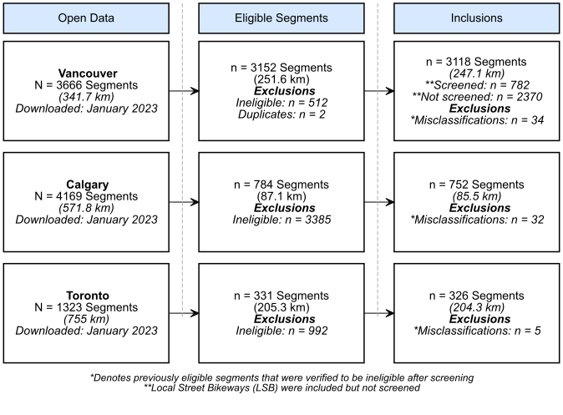

**Figure 1: Flow diagram of inclusion criteria for bikeway segments in Vancouver, Calgary, and Toronto**. This flowchart provides a high-level overview of the segment inclusions and exclusions for each municipality. Data from Calgary were specific to on-street routes only. For detailed flow diagrams specific to each municipality, please refer to the***Appendix****.*

***Verification of Installation and Upgrade Years***

Installation years were verified for all segments, and showed that 66% of included segments in Vancouver, 8% in Calgary, and 41% in Toronto had dedicated cycling infrastructure established by 2009 or earlier. In Vancouver, among segments installed or updated during the study period, 83.3% accurately matched the city's provided installation years, and 97.2% were within a ±1-year range. For Calgary, a smaller subset of segments 42.1% matched with the city's recorded installation years, and 62.7% were accurate within ±1 year. Finally, in Toronto, among 188 eligible segments, 74.5% accurately matched with the city's provided installation years, and 78.2% were accurate within a ±1-year span.

***Classification of Infrastructure***

For Vancouver, by December 2022 there were 41.2 km of painted infrastructure (*37.2 km painted lanes + 9.0 km buffered lanes*) and 30.6 km of cycle tracks following the verification of infrastructure classifications (***Appendix 1***). When contrasting these results with the original classifications (as provided by the city), the verified data had 3.2 km more cycle tracks and 2.4 km more painted infrastructure (***Table 1***). In Calgary, verified data for 2022 included 60.3 km of painted infrastructure (*55.5 km painted lanes + 4.8 km buffered lanes*) and 26.9 km cycle tracks. Accordingly, the verified data had 3.3 km more painted lanes and 4.8 km fewer protected lanes when compared to the administrative data. In Toronto, we found 151.4 km of painted infrastructure (*131.3 km painted lanes + 20 km buffered lanes*) and 73 km of cycle tracks, with 19.9 km more painted infrastructure and 0.9 km fewer cycle tracks compared with municipal records.

***Trends in New and Upgraded Infrastructure Installations***

There has been significant growth in dedicated on-street cycling networks since 2009 across all three cities. In 2009, Vancouver, Calgary, and Toronto had approximately 19 km, 1 km, and 18 km of cycling infrastructure per 1000 km of total roadway, respectively. Local street bikeways made up more than half of Vancouver’s cycling infrastructure at about 75 km per 1000 cen-km of total roadway. By 2022, the dedicated on-street cycling infrastructure in Vancouver had tripled (from XX to XX), a rate of similar growth to Toronto (xx to xx). Iin Calgary, the cycling infrastructure had increased eleven-fold (xx to xx). In 2009, only 4% of Vancouver's dedicated on-street cycling facilities were cycle tracks and none existed in Calgary or Toronto. This changed substantially by the end of the study period, with cycle tracks constituting 39.7% of Vancouver's, 30.9% of Calgary's, and 32.5% of Toronto's dedicated on-street infrastructure (***Figure 2***). This increase in cycle tracks has partly been driven by upgrades of existing painted lane infrastructure(***Figure 3***). This is particularly salient in Vancouver, which has seen decreases in painted lanes since 2016, as these routes are upgraded to infrastructure that physically separates cyclists from traffic.

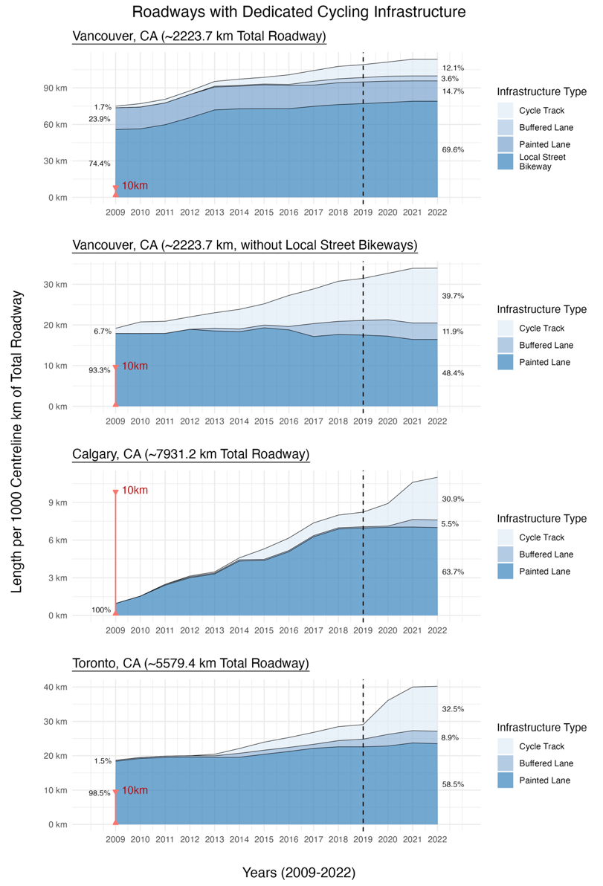

***Figure 2: Changes in dedicated cycling infrastructure between 2009 and 2021 for Vancouver, Calgary, and Toronto based by infrastructure category****. Assessed using roadway centreline-km, with infrastructure classifications determined by the most protective element present along each road segment.*

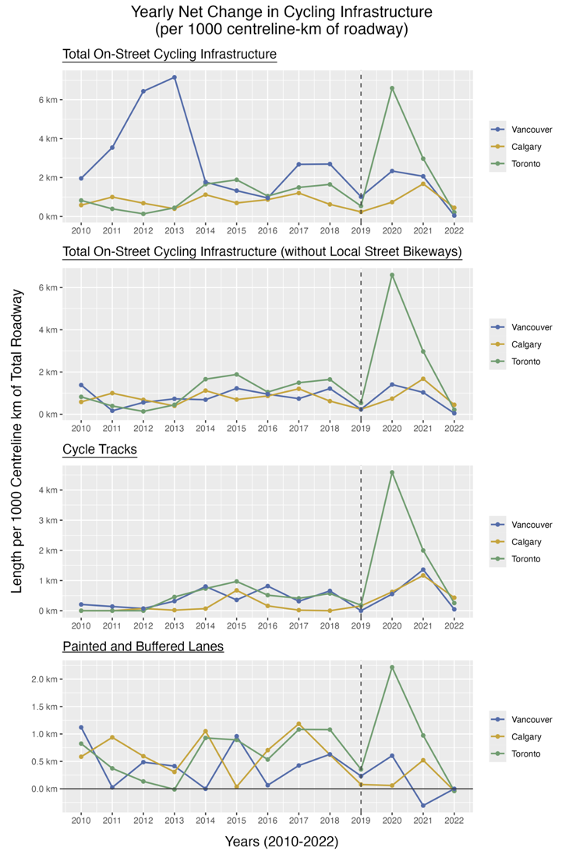

***Figure 3: Yearly net change in cycle route infrastructure by municipality, standardized per 1000 centerline-km of roadway.*** *The net change considers both the installation of new facilities, and the removal of existing infrastructure, such as when an existing facility is upgraded. Cycle route infrastructure is defined by the most protective element along a street centreline. This reflects the overall modifications made within each municipality over the course of the study period (2009-2022).*

***Impact of COVID-19 Pandemic on Infrastructure Installations***

. As illustrated in ***Figure 3***, the growth in infrastructure in Toronto and Vancouver infrastructure peaked in 2020, with over 6 km and 1 km of new infrastructure per 1000 cen-km of roadway installed respectively, while Calgary’s peak occurred in 2021, with over 1 km of new infrastructure built per 1000 cen-km of roadway. For Calgary and Toronto, this growth of on-street bikeways was primarily attributable to the increase in cycle tracks(***Figures 2 and 3)***.

A map of infrastructure – new and upgraded - following the onset of the pandemic is shown in ***Figure 4***. In Vancouver, 4% of the existing infrastructure was upgraded and 8% was newly installed. Calgary had less than 1% upgraded, but had 23% was newly installed. Finally, in Toronto 9% infrastructure was upgraded and 24% was newly installed.

A secondary analysis was conducted to identify the type of roads that experienced the most substantial increase in infrastructure since the start of the pandemic. Much of this increase stemmed from the introduction of cycle tracks on arterial roads. As seen in **Supplementary Figures** 4 to 6, between 2019 to 2022, cen-km for cycle tracks increased by about 45%, 83% and 300% in Vancouver, Calgary, and Toronto respectively. In contrast, less attention has been given to building protected facilities on collector roads in Vancouver and Calgary (which showed lower than 40% increase in cen-km between 2019 to 2022 respectively), and local roads in Vancouver and Toronto, with less than 10% of local roads being cycle tracks between 2019 to 2022. These trends in collector and local roads were not only since the start of the pandemic, but throughout the entire study period. As a result, as seen in **Figure 4** and **Supplementary Figures 1 to 3**, the cycling infrastructure across cities does not have segments entirely connected to form a continuous route across the network.

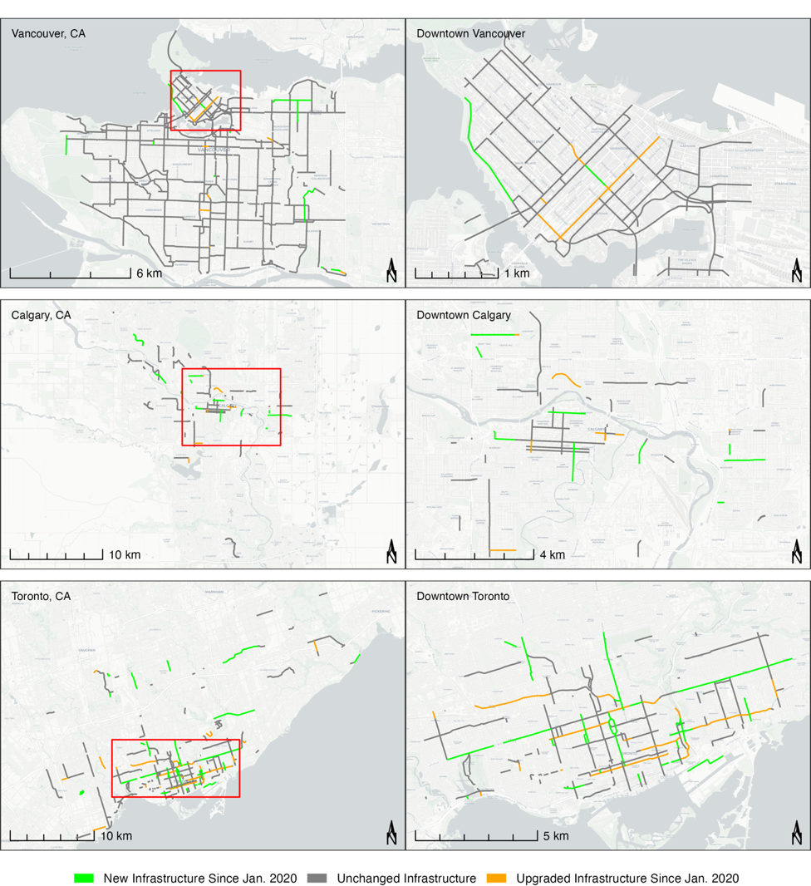

***Figure 4: Changes in Dedicated On-Street Infrastructure Since January 2020 for Vancouver, Calgary, and Toronto.*** *Basemap from OpenStreetMap and Carto (Positron).*

**DISCUSSION**

The objective of this study was to describe the trends in the implementation of on-street cycling infrastructure across Vancouver, Calgary, and Toronto from 2009 to 2022, using standardized criteria for classifying cycling infrastructure and leveraging street view imagery services. A consistent growth of the cycling network occurred in all three cities over the time period, with a shift towards protected cycling infrastructure. In addition to new installations, Toronto also prioritized the upgrading of existing infrastructure, with 9% of its current network of dedicated cycling routes being upgraded during this time, compared to 4% and less than 1% for Vancouver and Calgary, respectively. More recently, the COVID-19 pandemic revealed a divergence in municipal responses, with over twice the rate of new cycling infrastructure installations in Toronto from the onset of the pandemic, compared with Vancouver and Calgary.. The increase in cycling infrastructure related to the pandemic found in our study has also been demonstrated in other cities around the world (46–49). Buehler and Pucher review of cycling research after COVID-19 (March 2020-January 2023) (50) and found that expansions or bikeway network improvements accelerated during the pandemic, with a focus on protected bike lanes, traffic calming, slow streets and car-free streets.

Of note, was the lack of agreement between municipal reports of installation dates with the verified dates; 42% matching in Calgary, 75% in Toronto, and 83% in Vancouver. Needs expansion

In terms of road type, cycling infrastructure in Vancouver was mostly on local roadways (and mostly local street bikeways), while infrastructure in Calgary was relatively even across arterial, collector, and local roadways (with most cycling infrastructure in collector roadways being painted lanes as compared to arterial and local roadways). Toronto had most of its infrastructure on arterial roadways with the majority being painted lanes and a large growth in cycle tracks after 2019. Overall, the expansion of on-street cycling routes over the past decade is a reflection of the growing popularity of cycling as a mode of transportation (44), and investments in infrastructure having played a key role in supporting this upward trend (45).

Our study - in the Canadian context - offers valuable insights into cycling infrastructure implementation trends, with key strengths including the use of standardized criteria for classifying infrastructure and an innovative visual approach to confirm changes over time, as opposed to relying on municipal reports (which may be unreliable). Limitations of our study related to the classification of infrastructure and data availability. By defining infrastructure based on the most protective infrastructure, some finer details regarding infrastructure modifications may have been overlooked. Additionally, the exclusion of temporary infrastructure could have resulted in some selection bias in terms of the areas of the cities where temporary versus permanent infrastructure were located and may have limited the study's ability to fully capture how municipalities promoted active transportation, particularly during the pandemic. However, this study accurately reflects the permanent infrastructure that each city has installed to promote longer term cycling, after the start of the pandemic. Finally, given that each city updates data at different times, some relevant data may not have been captured at the time of data acquisition in January and May of 2023, thus there is a possibility that we did not fully capture all infrastructure from the start to end of 2022. This may explain the small changes in infrastructure from 2021 to 2022.

It must be noted, that despite these apparent advances in cycling infrastructure installation, the adoption of cycling has not grown equally among all groups and not everyone has equal access to cycling infrastructure. Lower income areas have been found to have poorer access to cycling infrastructure in parts of Canada. (51). There are also notable differences by sex with ridership levels among females often lower than men (44) (52). Both survey and observational research in other countries have also found a higher reported preference in women for off-street bikeways, cycle tracks and lower speed residential street bikeways and higher percentages of women cyclists on infrastructure separated from traffic and in low-speed areas with either bike lanes or raised median separating rides from traffic (53–55). This emphasizes the need to invest in ‘high comfort’ cycling infrastructure to address these barriers to equitable cycling.

The insights from this study also set the stage for more in-depth research into cycling infrastructure trends, particularly as they relate to equity and road safety. Identifying how municipalities have responded to existing gaps in cycling networks, particularly in relation to factors such as population density and neighbourhood marginalization, is important to promote healthy and equitable mobility for all. This detailed exploration helps shed light on these factors in urban planning and may contribute to a better understanding of how cycling infrastructure is prioritized and implemented across municipalities.

**CONCLUSIONS**

In summary, this comprehensive evaluation of on-street cycling infrastructure trends in Vancouver, Calgary, and Toronto from 2009 to 2022 provides insight into how municipalities have responded to an increased demand for permanent and safe cycling infrastructure. The study shows an expansion in dedicated cycling networks, particularly in the form of cycle tracks, reflecting a conscious shift toward safer and more “comfortable” cycling facilities. The COVID-19 pandemic has notably spurred an upward trend in infrastructure development in response to changing mobility patterns and evolving public health needs. These trends may indicate a larger paradigm shift, reflecting efforts to embrace active transportation and to rethink the design of urban centers (56). Discrepancies and misclassifications within municipal cycling network data and the poor reliability of infrastructure implementation dates points to the fact that these data are not collected for the purpose of evaluation or research. This underscores the need for standardized classifications for infrastructure and accurate implementation data to facilitate effective urban planning and policymaking. Despite some progress, the findings also point to a need for continued investment to address disconnected cycling networks, particularly as protected facilities were often less common along medium-traffic collector roads. By investing in more inclusive and connected cycling networks that align with the Vision Zero road safety plan, municipalities can foster safer, more sustainable, and resilient mobility in cities.

**REFERENCES:**

1. Gordon C. Economic Benefits of Active Transportation. In: Larouche R, ed. *Children’s Active Transportation*. Elsevier; 2018 (Accessed August 15, 2023):39–52. (https://www.sciencedirect.com/science/article/pii/B978012811931000003X). (Accessed August 15, 2023)

2. Pucher J, Buehler R. Cycling towards a more sustainable transport future. *Transport Reviews* [electronic article]. 2017;37(6):689–694. (https://doi.org/10.1080/01441647.2017.1340234). (Accessed August 15, 2023)

3. Brand C, Dons E, Anaya-Boig E, et al. The climate change mitigation effects of daily active travel in cities. *Transportation Research Part D: Transport and Environment* [electronic article]. 2021;93:102764. (https://www.sciencedirect.com/science/article/pii/S1361920921000687). (Accessed August 15, 2023)

4. Pucher J, Dill J, Handy S. Infrastructure, programs, and policies to increase bicycling: An international review. *Preventive Medicine* [electronic article]. 2010;50:S106–S125. (https://www.sciencedirect.com/science/article/pii/S0091743509004344). (Accessed August 15, 2023)

5. Pucher J, Buehler R. Sustainable Transport in Canadian Cities: Cycling Trends and Policies. *Berkeley Planning Journal* [electronic article]. 2006;19(1). (https://escholarship.org/uc/item/0rr0t06s). (Accessed May 26, 2024)

6. Aboelata M, Yanez E, Kharrazi R. Vision Zero: a health equity road map for getting to zero in every community. *Prevention Institute*. 2017;1–11.

7. Parachute. Vision Zero map – Parachute. 2023;(https://parachute.ca/en/program/vision-zero/vision-zero-map/). (Accessed May 26, 2024)

8. Belin M-Å, Tillgren P, Vedung E. Vision Zero – a road safety policy innovation. *International Journal of Injury Control and Safety Promotion*. 2012;19(2):171–179.

9. Stephanie Cowle, Pamela Fuselli, Fahra Rajabali, et al. The Cost of Transport Injuries in Canada. Sudbury, Ontario: 2022:7.(https://carsp.ca/en/presentations-and-papers/carsp-hybrid-conference-sudbury-2022/the-cost-of-transport-injuries-in-canada-2/)

10. Toronto Police Service. Cyclists KSI Collisions. 2023;(https://data.torontopolice.on.ca/pages/cyclists). (Accessed May 26, 2024)

11. Toronto (Ont.), Health TP. Road to health: improving walking and cycling in Toronto. 2012.

12. Parachute. Cost of Injury in Canada The highest costs: Falls and transport. *Parachute*. 2022;(https://parachute.ca/en/professional-resource/cost-of-injury-in-canada/the-highest-costs-falls-and-transport/). (Accessed June 12, 2024)

13. Doran A, El-Geneidy A, Manaugh K. The pursuit of cycling equity: A review of Canadian transport plans. *Journal of Transport Geography* [electronic article]. 2021;90:102927. (https://www.sciencedirect.com/science/article/pii/S0966692320310048). (Accessed August 15, 2023)

14. Batomen B, Cloutier M-S, Palm M, et al. Frequent public transit users views and attitudes toward cycling in Canada in the context of the COVID-19 pandemic. *Multimodal Transportation*. 2023;2(2):100067.

15. Winters M, Zanotto M, Butler G. At-a-glance - The Canadian Bikeway Comfort and Safety (Can-BICS) Classification System: a common naming convention for cycling infrastructure. *Health Promot Chronic Dis Prev Can* [electronic article]. 2020;40(9):288–293. (https://www.ncbi.nlm.nih.gov/pmc/articles/PMC7534561/). (Accessed August 10, 2023)

16. Gössling S, McRae S. Subjectively safe cycling infrastructure: New insights for urban designs. *Journal of Transport Geography* [electronic article]. 2022;101:103340. (https://www.sciencedirect.com/science/article/pii/S0966692322000631). (Accessed August 15, 2023)

17. Fischer J, Winters M. COVID-19 street reallocation in mid-sized Canadian cities: socio-spatial equity patterns. *Can J Public Health* [electronic article]. 2021;112(3):376–390. (https://doi.org/10.17269/s41997-020-00467-3). (Accessed August 15, 2023)

18. CIHI. Injury and Trauma Emergency Department and Hospitalization Statistics, 2020–2021. 2022;(https://www.cihi.ca/sites/default/files/document/injury-trauma-emergency-dept-hospitalizations-2020-2021-data-tables-en.xlsx). (Accessed April 26, 2023)

19. Canadian Institute for Health Information (CIHI). National Ambulatory Care Reporting System metadata (NACRS). 2023;(www.cihi.ca/en/national-ambulatory-care-reporting-system-metadata-nacrs). (Accessed April 27, 2023)

20. Batomen B, Macpherson A, Lewis J, et al. Vulnerable road user injury trends following the COVID-19 pandemic in Toronto, Canada: An interrupted time series analysis. *Journal of Safety Research*. 2024;89:152–159.

21. Batomen B, Cloutier M-S, Palm M, et al. Frequent public transit users views and attitudes toward cycling in Canada in the context of the COVID-19 pandemic. *Multimodal Transportation* [electronic article]. 2023;2(2):100067. (https://www.sciencedirect.com/science/article/pii/S2772586322000673). (Accessed April 28, 2023)

22. Ferster C, Fischer J, Manaugh K, et al. Using OpenStreetMap to inventory bicycle infrastructure: A comparison with open data from cities. *International Journal of Sustainable Transportation*. 2020;14(1):64–73.

23. Ferster C, Nelson T, Manaugh K, et al. Developing a national dataset of bicycle infrastructure for Canada using open data sources. *Environment and Planning B: Urban Analytics and City Science*. 2023;50(9):2543–2559.

24. Winters M, Beairsto J, Ferster C, et al. The Canadian Bikeway Comfort and Safety metrics (Can-BICS): National measures of the bicycling environment for use in research and policy. *Health reports*. 2022;33(10):3–13.

25. Nelson T, Ferster C, Laberee K, et al. Crowdsourced data for bicycling research and practice. *Transport Reviews*. 2021;41(1):97–114.

26. Teschke K, Harris MA, Reynolds CCO, et al. Route Infrastructure and the Risk of Injuries to Bicyclists: A Case-Crossover Study. *Am J Public Health*. 2012;102(12):2336–2343.

27. Boss D, Nelson T, Winters M. Monitoring city wide patterns of cycling safety. *Accident Analysis & Prevention*. 2018;111:101–108.

28. Ravensbergen L, Buliung R, Laliberté N. Fear of cycling: Social, spatial, and temporal dimensions. *Journal of Transport Geography*. 2020;87:102813.

29. Zhao Q, Winters M, Nelson T, et al. Who has access to cycling infrastructure in Canada? A social equity analysis. *Computers, Environment and Urban Systems*. 2024;110:102109.

30. Winters M, Branion-Calles M, Therrien S, et al. Impacts of Bicycle Infrastructure in Mid-Sized Cities (IBIMS): protocol for a natural experiment study in three Canadian cities. *BMJ Open*. 2018;8(1):e019130.

31. Tabascio A, Tiznado-Aitken I, Harris D, et al. Assessing the potential of cycling growth in Toronto, Canada. *International Journal of Sustainable Transportation*. 2023;17(12):1370–1383.

32. Branion-Calles M, Nelson T, Fuller D, et al. Associations between individual characteristics, availability of bicycle infrastructure, and city-wide safety perceptions of bicycling: A cross-sectional survey of bicyclists in 6 Canadian and U.S. cities. *Transportation Research Part A: Policy and Practice*. 2019;123:229–239.

33. Berghoefer FL, Vollrath M. Prefer what you like? Evaluation and preference of cycling infrastructures in a bicycle simulator. *Journal of Safety Research*. 2023;87:157–167.

34. Assunçao-Denis M-È, Tomalty R. Increasing cycling for transportation in Canadian communities: Understanding what works. *Transportation Research Part A: Policy and Practice*. 2019;123:288–304.

35. Orvin MM, Fatmi MR, Chowdhury S. Taking another look at cycling demand modeling: A comparison between two cities in Canada and New Zealand. *Journal of Transport Geography*. 2021;97:103220.

36. Toronto Transportation Services. Cycling Network - Open Data. 2023;(https://open.toronto.ca/dataset/)

37. City of Vancouver Engineering Services. Bikeways - Open Data Portal. (https://opendata.vancouver.ca/explore/dataset/bikeways/information)

38. City of Calgary Cap Priorities and Invstmnt. Calgary Bikeways | Open Calgary. (https://data.calgary.ca/Transportation-Transit/Calgary-Bikeways/jjqk-9b73). (Accessed August 10, 2023)

39. Nolan J, Sinclair J, Savage J. Are bicycle lanes effective? The relationship between passing distance and road characteristics. *Accident Analysis & Prevention* [electronic article]. 2021;159:106184. (https://www.sciencedirect.com/science/article/pii/S0001457521002153). (Accessed August 13, 2023)

40. Pebesma E, Bivand R, Racine E, et al. sf: Simple Features for R. 2024;(https://cran.r-project.org/package=sf). (Accessed May 16, 2024)

41. R Core Team. R: A language and environment for statistical computing. 2022;(https://www.R-project.org/)

42. ArcGIS Pro Mapping Software. Version 3.1.2. 2023;(https://www.esri.com/en-us/home)

43. Government of Canada SC. Census Profile, 2021 Census of Population. 2022;(https://www12.statcan.gc.ca/census-recensement/2021/dp-pd/prof/index.cfm?Lang=E). (Accessed August 10, 2023)

44. Pucher J, Buehler R, Seinen M. Bicycling renaissance in North America? An update and re-appraisal of cycling trends and policies. *Transportation Research Part A: Policy and Practice* [electronic article]. 2011;45(6):451–475. (https://www.sciencedirect.com/science/article/pii/S0965856411000474). (Accessed August 17, 2023)

45. Mölenberg FJM, Panter J, Burdorf A, et al. A systematic review of the effect of infrastructural interventions to promote cycling: strengthening causal inference from observational data. *International Journal of Behavioral Nutrition and Physical Activity* [electronic article]. 2019;16(1):93. (https://doi.org/10.1186/s12966-019-0850-1). (Accessed August 17, 2023)

46. Kraus S, Koch N. Provisional COVID-19 infrastructure induces large, rapid increases in cycling. *Proc. Natl. Acad. Sci. U.S.A.* 2021;118(15):e2024399118.

47. Sunio V, Mateo-Babiano I. Pandemics as ‘windows of opportunity’: Transitioning towards more sustainable and resilient transport systems. *Transport policy*. 2022;116:175–187.

48. Rérat P, Haldimann L, Widmer H. Cycling in the era of Covid-19: The effects of the pandemic and pop-up cycle lanes on cycling practices. *Transportation research interdisciplinary perspectives*. 2022;15:100677.

49. Buehler R, Pucher J. Cycling through the COVID-19 Pandemic to a More Sustainable Transport Future: Evidence from Case Studies of 14 Large Bicycle-Friendly Cities in Europe and North America. *Sustainability* [electronic article]. 2022;14(12):7293. (https://www.mdpi.com/2071-1050/14/12/7293). (Accessed August 17, 2023)

50. Buehler R, Pucher J. COVID-19 and cycling: a review of the literature on changes in cycling levels and government policies from 2019 to 2022. *Transport Reviews*. 2024;44(2):299–344.

51. Winters M, Fischer J, Nelson T, et al. Equity in Spatial Access to Bicycling Infrastructure in Mid-Sized Canadian Cities. *Transportation Research Record*. 2018;2672(36):24–32.

52. Teschke K, Chinn A, Brauer M. Proximity to four bikeway types and neighborhood-level cycling mode share of male and female commuters. *Journal of transport and land use*. 2017;10(1):695–713.

53. Debnath AK, Haworth N, Heesch KC. Women cycling in Queensland: Results from an observational study. *Accident Analysis & Prevention*. 2021;151:105980.

54. Garrard J, Rose G, Lo SK. Promoting transportation cycling for women: the role of bicycle infrastructure. *Preventive medicine*. 2008;46(1):55–59.

55. Aldred R, Elliott B, Woodcock J, et al. Cycling provision separated from motor traffic: a systematic review exploring whether stated preferences vary by gender and age. *Transport Reviews*. 2017;37(1):29–55.

56. Nikitas A, Tsigdinos S, Karolemeas C, et al. Cycling in the Era of COVID-19: Lessons Learnt and Best Practice Policy Recommendations for a More Bike-Centric Future. *Sustainability* [electronic article]. 2021;13(9):4620. (https://www.mdpi.com/2071-1050/13/9/4620). (Accessed August 17, 2023)

**APPENDIX 1 – SUPPLEMENTARY RESULTS**

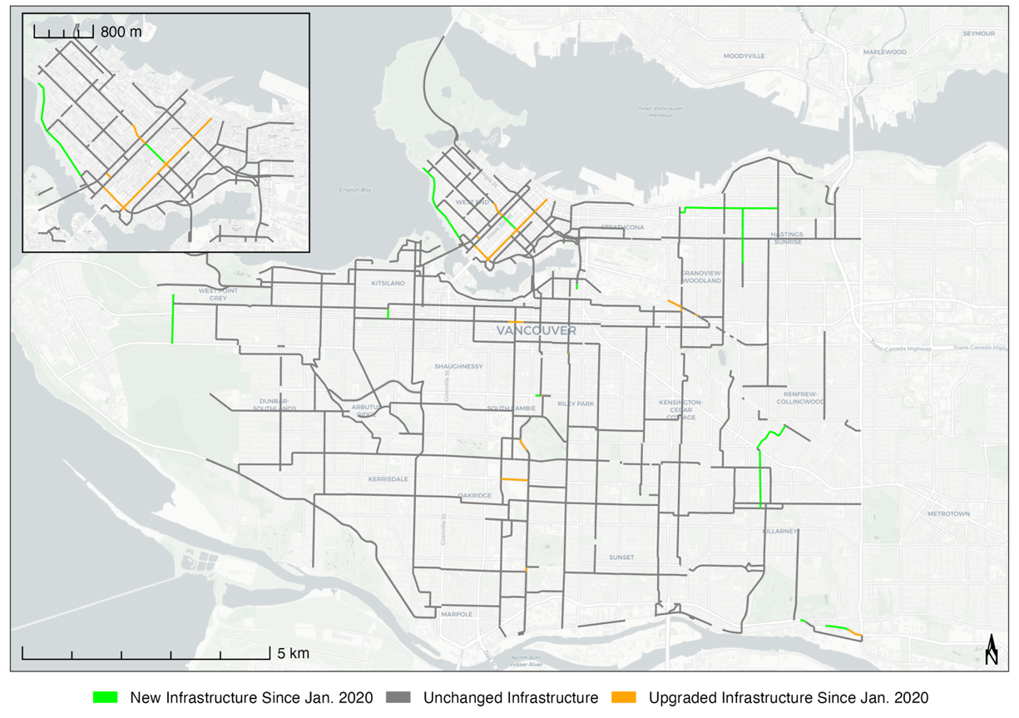

***Supplementary Figure 1: Enlarged Map. Changes in Dedicated On-Street Infrastructure Between 2020-2021 for the Municipality of Vancouver, CA.*** *New installations of dedicated infrastructure are denoted in green, upgrades from a previous dedicated infrastructure type are denoted in orange. Basemap from OpenStreetMap and Carto (Positron).*

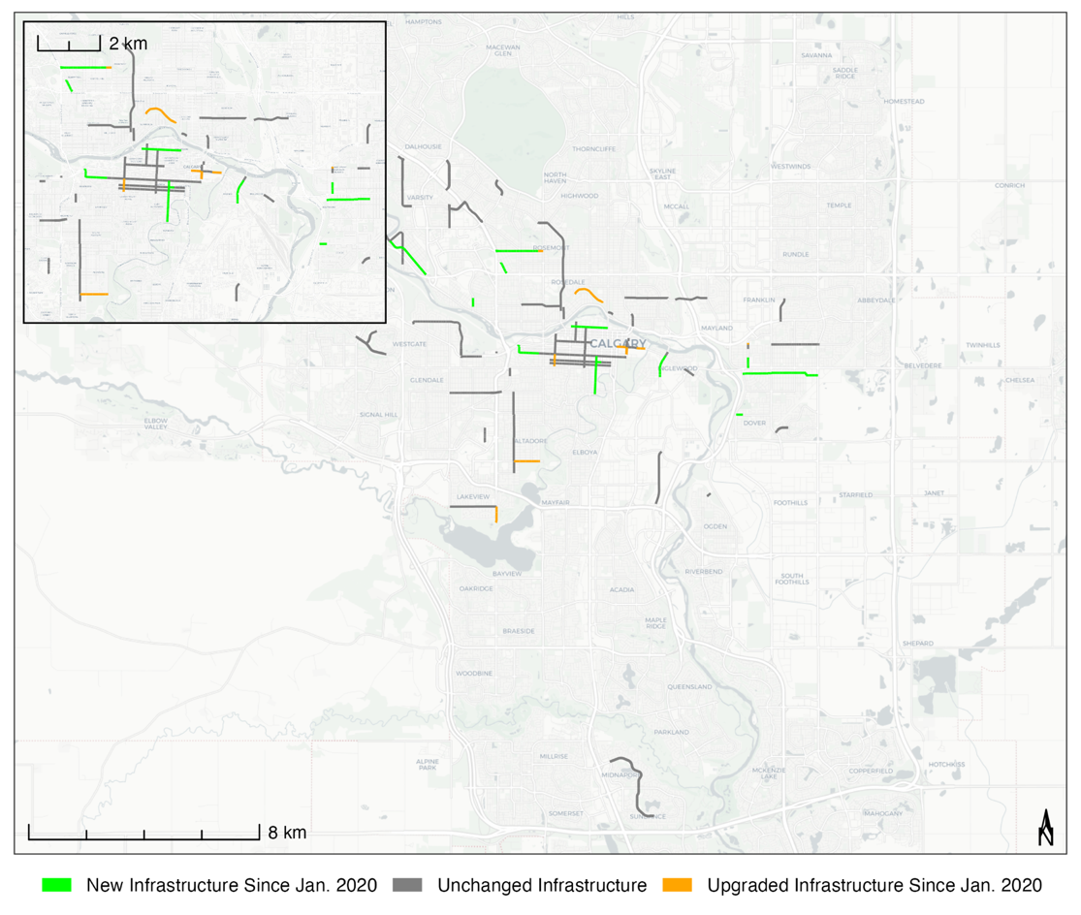

***Supplementary Figure 2: Enlarged Map. Changes in Dedicated On-Street Infrastructure Between 2020-2022 for the Municipality of Calgary, CA.*** *New installations of dedicated infrastructure are denoted in green, upgrades of dedicated infrastructure are denoted in orange. Basemap from OpenStreetMap and Carto (Positron).*

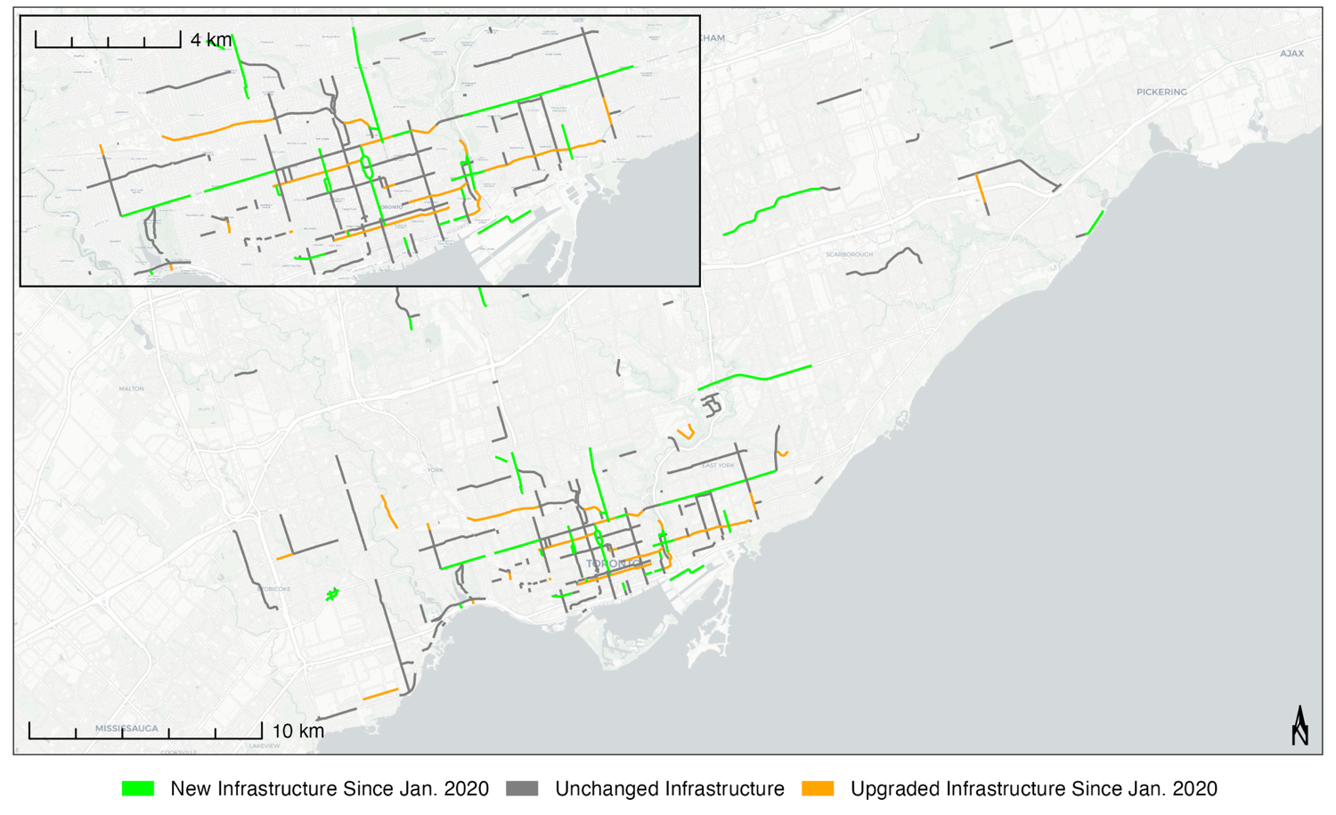

***Supplementary Figure 3: Enlarged Map. Changes in Dedicated On-Street Infrastructure Between 2020-2022 for the Municipality of Toronto, CA.*** *New installations of dedicated infrastructure are denoted in green, upgrades of dedicated infrastructure are denoted in orange. Basemap from OpenStreetMap and Carto (Positron).*

|  |  |  |  |  |  |  |  |  |  |  |  |  |  |  |  |
| --- | --- | --- | --- | --- | --- | --- | --- | --- | --- | --- | --- | --- | --- | --- | --- |
|  | **Total Length of Roadways with Dedicated Cycling Infrastructure by Year (2009-2022)**  *Measured by centreline-km of roadway* | | | | | | | | | | | | | | |
| **Vancouver** | | | | | **Calgary** | | | |  | **Toronto** | | | |  |
| Year | PL | BUF | CT | **TOTAL** | Change | PL | BUF | CT | **TOTAL** | Change | PL | BUF | CT | **TOTAL** | Change |
| 2009 | 39.8 | 0 | 2.84 | **42.64** |  | 7.58 | 0 | 0 | **7.58** |  | 102.57 | 1.56 | 0 | **104.13** |  |
| 2010 | 39.78 | 0 | 6.33 | **46.11** | *+3.47* | 12.22 | 0 | 0 | **12.22** | *+4.64* | 107.17 | 1.56 | 0 | **108.73** | *+4.6* |
| 2011 | 39.84 | 0 | 6.64 | **46.48** | *+0.37* | 19.11 | 0.55 | 0 | **19.66** | *+7.44* | 108.72 | 2.08 | 0 | **110.8** | *+2.07* |
| 2012 | 42.41 | 0 | 6.8 | **49.21** | *+2.73* | 23.82 | 0.55 | 0.56 | **24.93** | *+5.27* | 109.47 | 2.08 | 0 | **111.55** | *+0.75* |
| 2013 | 41.82 | 1.5 | 8.76 | **52.08** | *+2.87* | 26.26 | 0.55 | 0.7 | **27.51** | *+2.58* | 108.95 | 2.54 | 2.55 | **114.04** | *+2.49* |
| 2014 | 41.41 | 1.5 | 11.37 | **54.28** | *+2.2* | 34.41 | 0.73 | 1.25 | **36.39** | *+8.88* | 109.13 | 6.42 | 7.75 | **123.3** | *+9.26* |
| 2015 | 43.54 | 1.5 | 12.3 | **57.34** | *+3.06* | 34.71 | 0.73 | 6.61 | **42.05** | *+5.66* | 113.99 | 6.55 | 13.16 | **133.7** | *+10.4* |
| 2016 | 42.43 | 1.85 | 17.66 | **61.94** | *+4.6* | 40.28 | 0.74 | 7.88 | **48.9** | *+6.85* | 118.57 | 6.55 | 16.03 | **141.15** | *+7.45* |
| 2017 | 38.77 | 7.09 | 19.6 | **65.46** | *+3.52* | 49.68 | 0.74 | 8.03 | **58.45** | *+9.55* | 123.6 | 6.55 | 19.44 | **149.59** | *+8.44* |
| 2018 | 39.9 | 7.18 | 22.63 | **69.71** | *+4.25* | 54.61 | 0.74 | 8.03 | **63.38** | *+4.93* | 126.08 | 10.08 | 22.62 | **158.78** | *+9.19* |
| 2019 | 39.59 | 8 | 23.67 | **71.26** | *+1.55* | 55.23 | 0.74 | 9.28 | **65.25** | *+1.87* | 126.07 | 12.45 | 23.63 | **162.15** | *+3.37* |
| 2020 | 38.96 | 9 | 26.04 | **74** | *+2.74* | 55.7 | 0.74 | 14.23 | **70.67** | *+5.42* | 127.38 | 18.85 | 55.11 | **201.34** | *+39.19* |
| 2021 | 37.19 | 9 | 30.58 | **76.77** | *+2.77* | 55.82 | 4.76 | 23.5 | **84.08** | *+13.41* | 132.35 | 20.03 | 70.82 | **223.2** | *+21.86* |
| 2022 | 37.19 | 9 | 30.68 | **76.87** | *+0.1* | 55.52 | 4.76 | 26.93 | **87.21** | *+3.13* | 131.34 | 20.03 | 73.01 | **224.38** | *+1.18* |

***Supplementary Table 1: Total Length of Dedicated On-Street Cycling Infrastructure between 2009 and 2022, for Vancouver, Calgary, and Toronto (Canada).*** *Each entry denotes the aggregated length of infrastructure existing at the conclusion the calendar year. Lengths are measured in roadway centreline-km, with cycling infrastructure classified according to the side of the road featuring the most protective element. Rows noted in light red denote infrastructure changes following the start of the COVID-19 pandemic. Geodesic lengths calculated in ArcGIS Pro 3.0.1.*

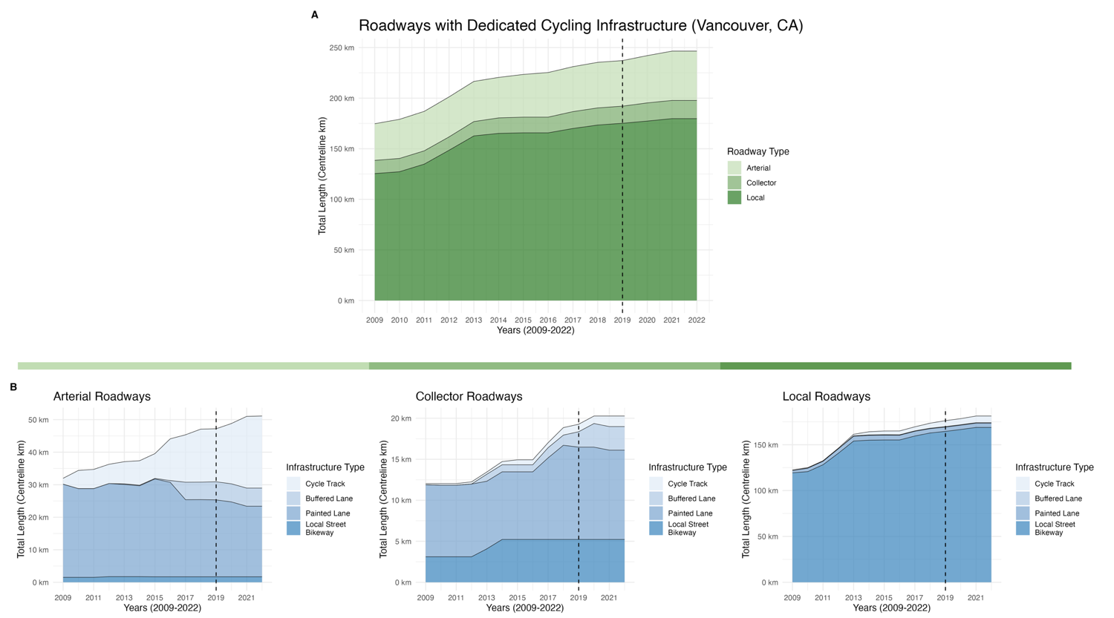

***Supplementary Figure 4: Changes in dedicated cycling infrastructure between 2009 and 2021 for the Municipality of Vancouver, CA*** *by (A) roadway classification, and (B) infrastructure distribution within each road class. Assessed using roadway centreline-km, with infrastructure classification determined by the most protective element present along each road segment.*

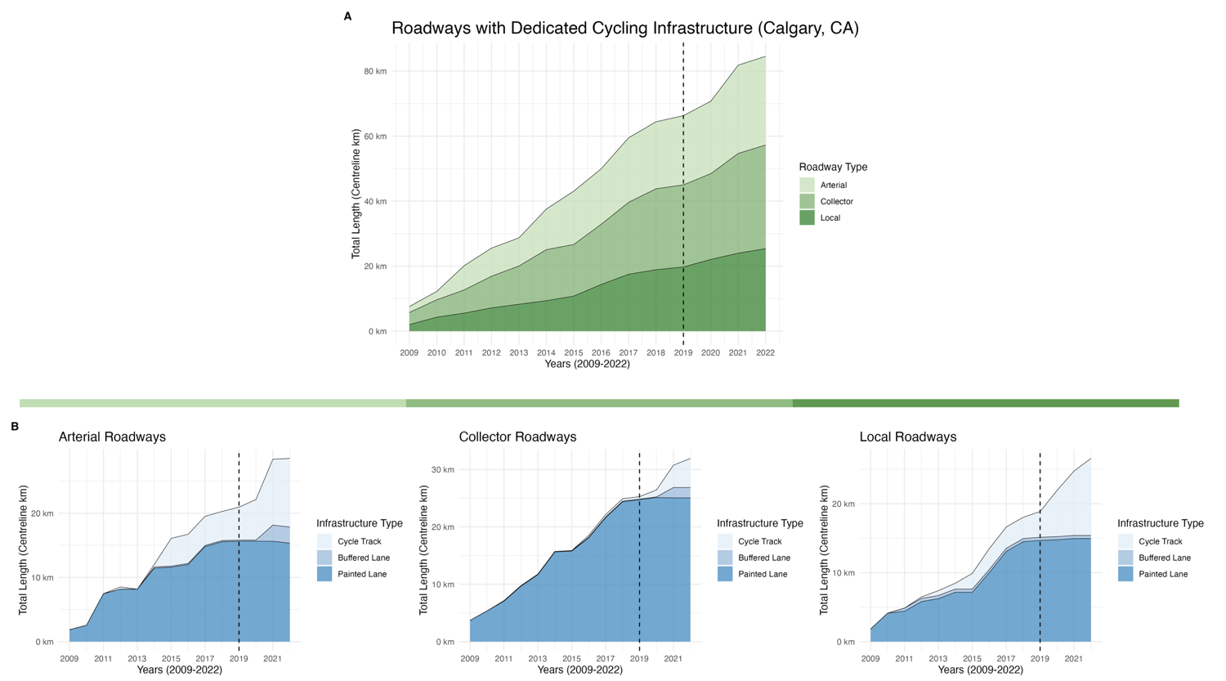

***Supplementary Figure 5: Changes in dedicated cycling infrastructure between 2009 and 2022 for the Municipality of Calgary, CA*** *by (A) roadway classification, and (B) infrastructure distribution within each road class. Assessed using roadway centreline-km, with infrastructure classification determined by the most protective element present along each road segment.*

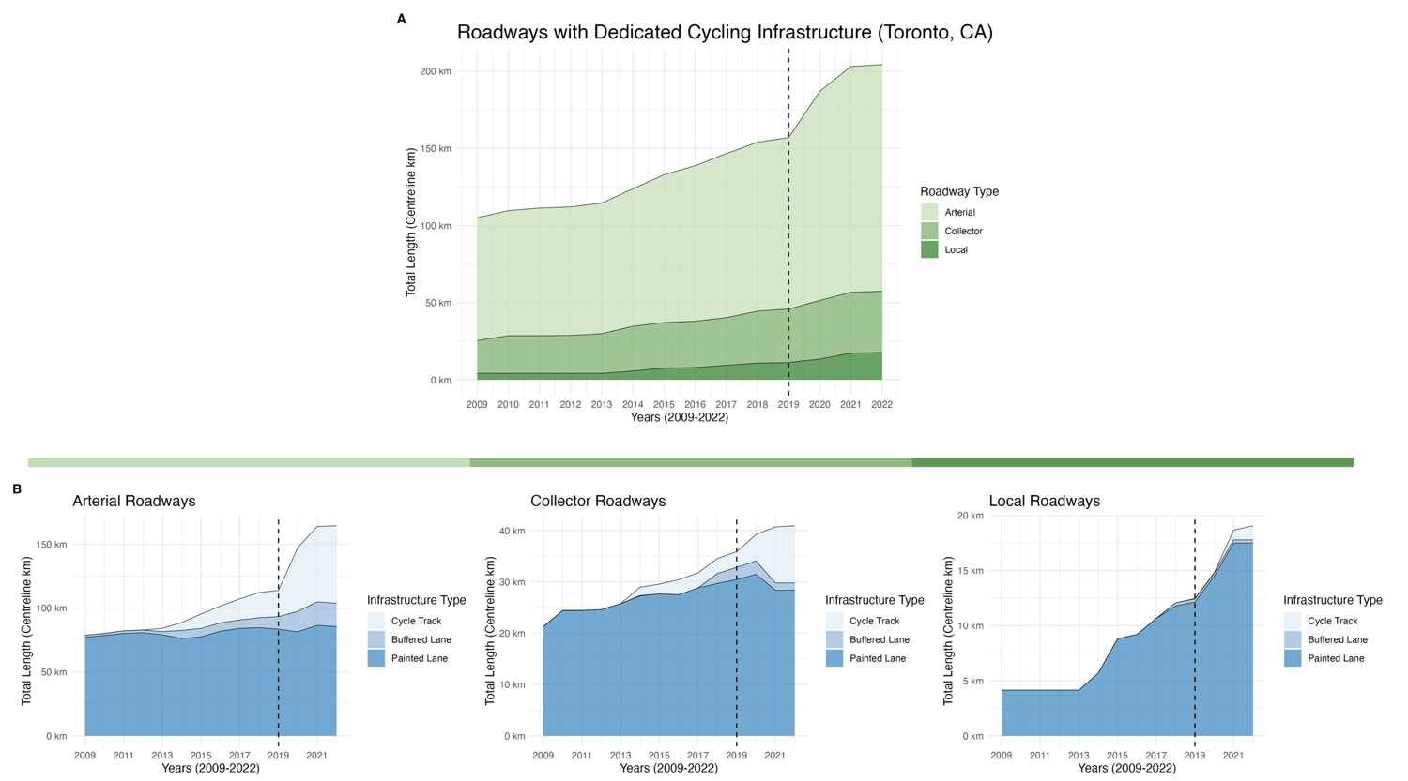

***Supplementary Figure 6: Changes in dedicated cycling infrastructure between 2009 and 2022 for the Municipality of Toronto, CA*** *by (A) roadway classification, and (B) infrastructure distribution within each road class. Assessed using roadway centreline-km, with infrastructure classification determined by the most protective element present along each road segment.*

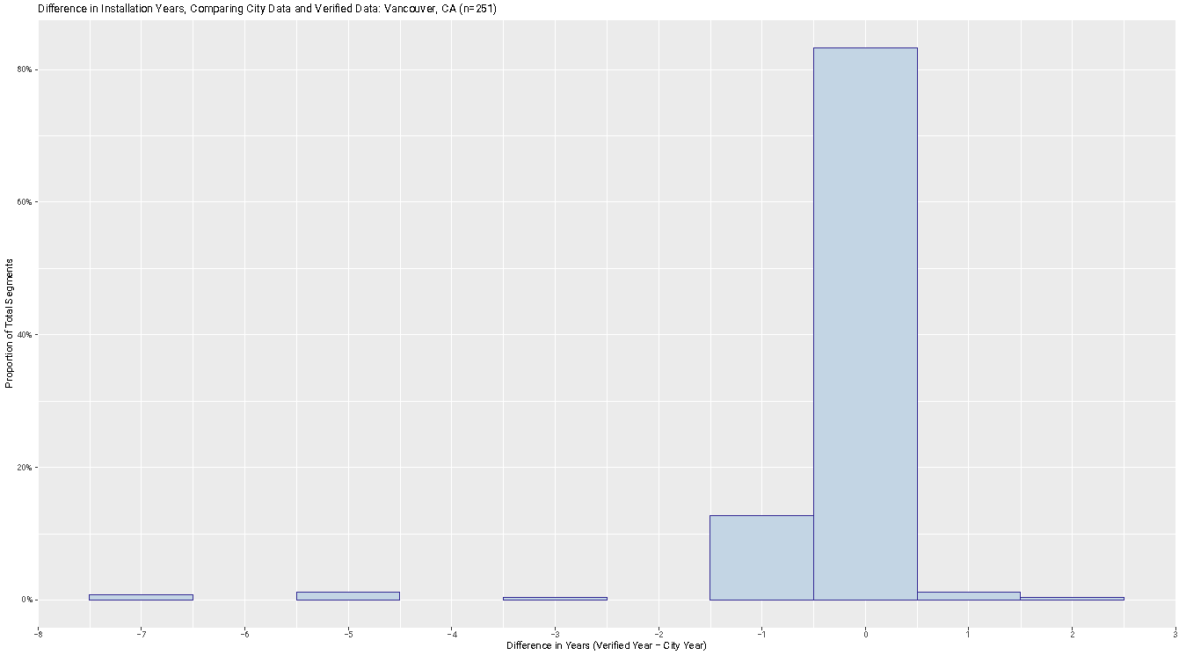

***Supplementary Figure 7: A comparative analysis between municipal data and verified data on the installation years for cycling infrastructure in Vancouver, CA.*** *Any data where a city provided and verified installation years were missing or the verified year occurred earlier or equal to the start of the study period (2009) has been excluded from analysis, yielding n=251 segments. The graph shows that 83.3% of the included segments had the correct installation year as per the city’s data, and 97.2% were accurate within a range of ±1 year.*

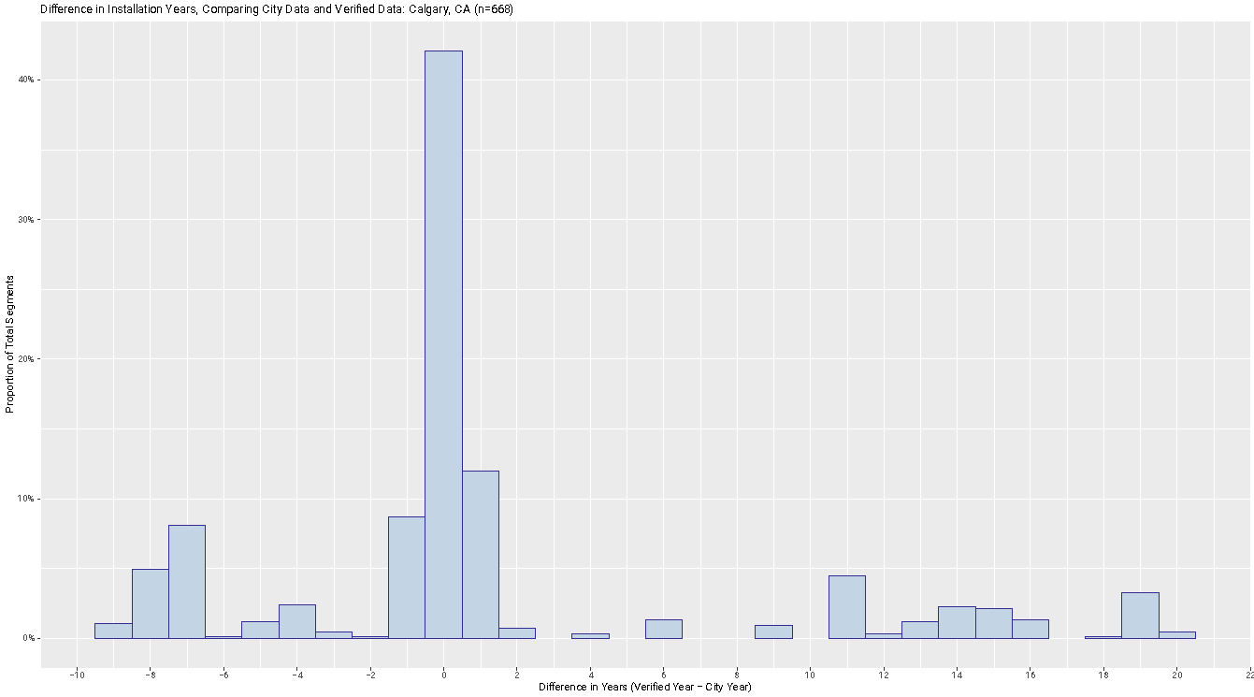

***Supplementary Figure 8: A comparative analysis between municipal data and verified data on the installation years for cycling infrastructure in Calgary, CA.*** *Any data where a city provided and verified installation years were missing or the verified year occurred earlier or equal to the start of the study period (2009) has been excluded from analysis, yielding n=668 segments. The graph shows that 42.1% of the included segments had the correct installation year as per the city’s data, and 62.7% were accurate within a range of ±1 year.*

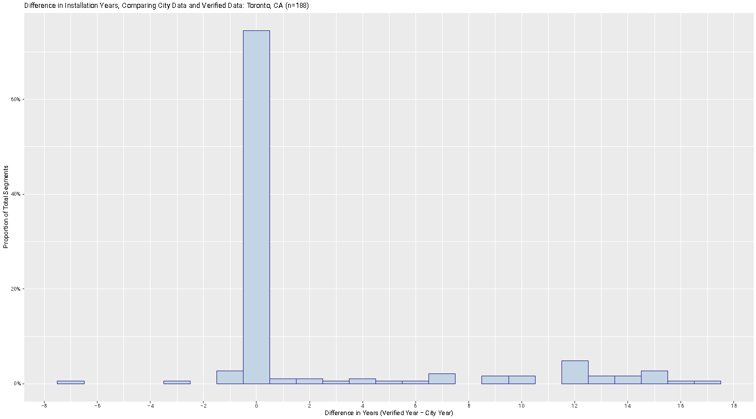

***Supplementary Figure 9: A comparative analysis between municipal data and verified data on the installation years for cycling infrastructure in Toronto, CA.*** *Any data where a city provided and verified installation years were missing or the verified year occurred earlier or equal to the start of the study period (2009) has been excluded from analysis, yielding n=188 segments. The graph shows that 74.5% of the included segments had the correct installation year as per the city’s data, and 78.2% were accurate within a range of ±1 year.*

**APPENDIX 2 – METHODOLOGY**

**Segment Inclusion Criteria for Vancouver**

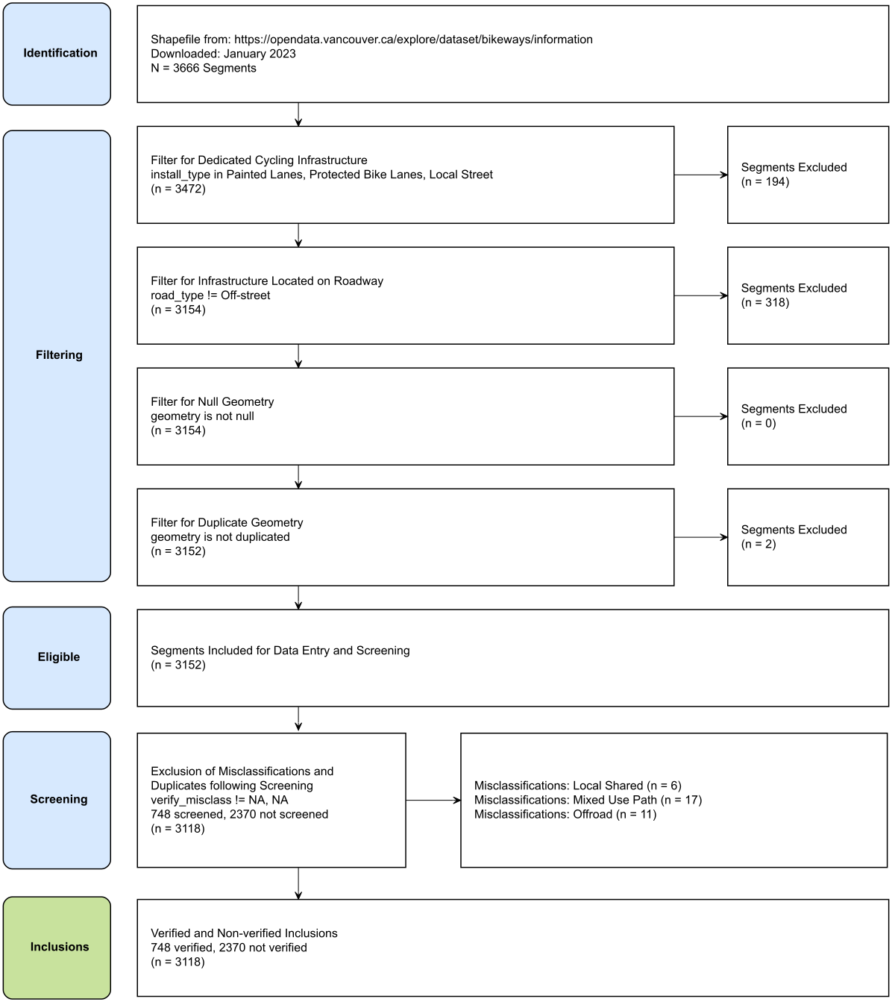

**Segment Inclusion Criteria for Calgary**

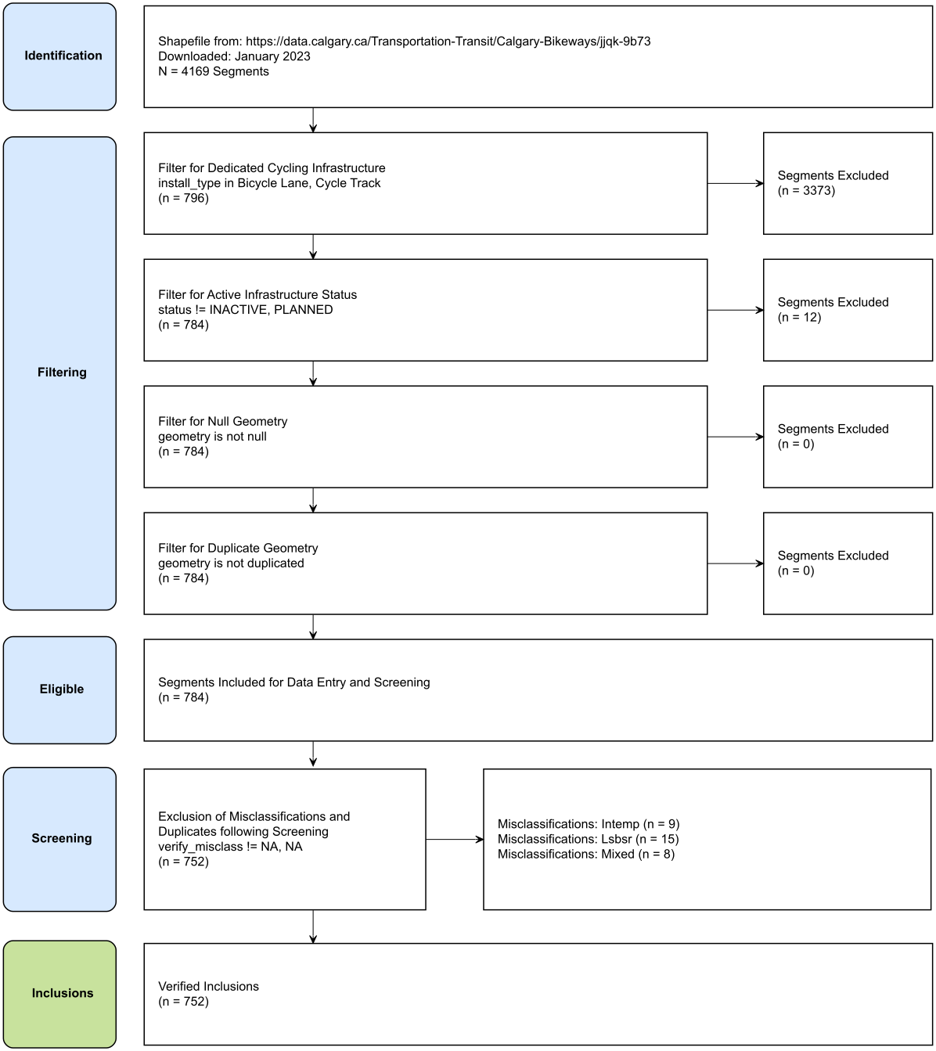

**Segment Inclusion Criteria for Toronto**

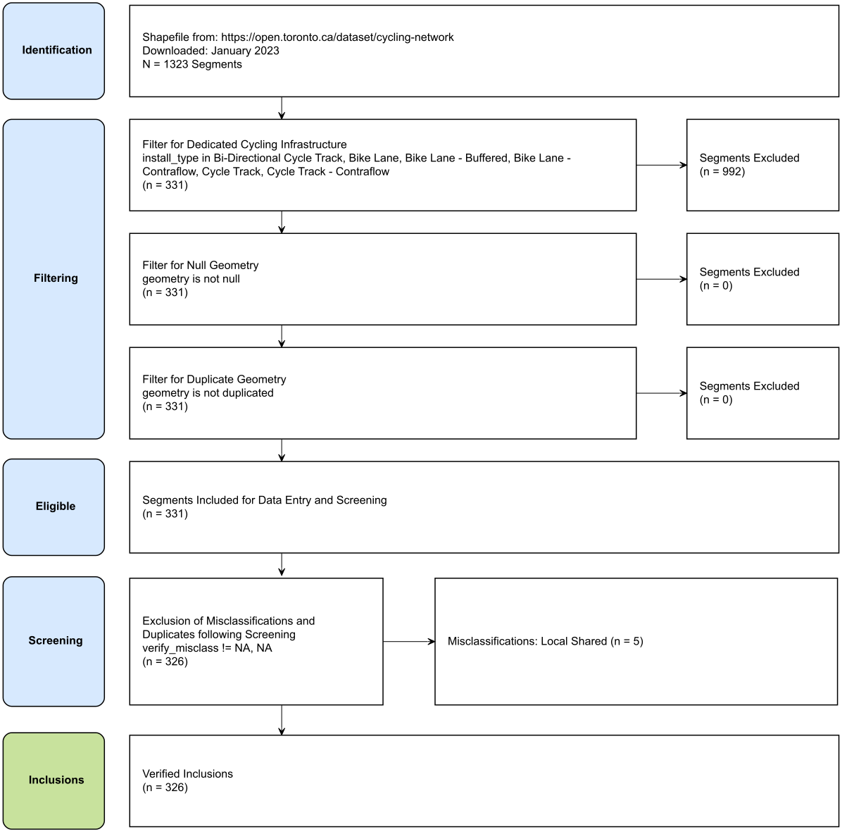

|  |
| --- |
| ***Criteria for Classifying Infrastructure*** |
| **Overview of Steps**  Infrastructure Classification Steps:   * Classify dedicated on-street cycling infrastructure types as either a painted lane, buffered painted lane, or cycle track based on the criteria listed below. Where dedicated on-street cycling infrastructure is absent for a specific segment, the segment will be classified as a shared road, and excluded if it did not receive a subsequent upgrade to a dedicated cycling infrastructure type. Where the cycling facility is located >10 m from a roadway or is denoted for shared use with pedestrians, the segment will be excluded. * If differing infrastructure types exist on either side of the road, categorize the segment based on the most protective element of dedicated cycling infrastructure: Cycle Track (most protective) > Buffered Painted Lane > Painted Lane > Shared Road. * When different infrastructure types are observed along one side of a roadway segment, the classification will rely on the predominant infrastructure type present along the majority of the route, with infrastructure present at intersections excluded from consideration. |
| **Criteria for Painted Lane, Modified from Can-BICS** (15)**:**  A cycling facility can be considered a painted bike lane if the design is consistent with the following features:   1. Lane Demarcation: Solid or dashed lane line(s).    1. Lane may be solid or dashed on the travel lane side. 2. Route Signage and Pavement Markings: Lane must include either of the following at the site or between the site and nearest intersection (≤ 250 m from the site):    1. Bicycle symbols painted on the road (reserved lane diamond optional).    2. Reserved lane sign (for bicycles) or bicycle symbols on signs (cycling route wayfinding signs).    3. Shoulders lacking any bicycle stencils or signage as outlined above are considered ‘paved shoulders’ and should not be considered cycling infrastructure. 3. Auto parking prohibited: Curbside motor vehicle parking is prohibited with 'no parking' or 'no stopping' signs or equivalent pavement markings.    1. Only applicable to painted bike lanes adjacent to the curb, without a designated parking lane. |
| **Criteria for Buffered Painted Lane:**  A cycling facility can be considered a buffered bike lane if the design is consistent with the following features of a painted lane, in addition to:   1. Lane Demarcation: Solid lines    1. Lane must be buffered on the travel lane side and may be unbuffered or buffered on parking lane side (if parking is available).    2. The buffered delineation measures a minimum width of 1 foot (> 30 centimeters) and exhibits diagonal striping or chevron markings. |
| **Criteria for Cycle Track, Selected from Can-BICS** (15)**:**  A cycling facility can be considered a cycle track if the design is consistent with the following features:   1. Physical Separation: The cycle track is physically separated from the roadway (the portion of the road that vehicles can travel) and this ***separation has a vertical component.***    1. Where automobile parking is the physical separation, permanent vertical elements such as bollards, a curb, raised median, planter boxes, or street furniture (e.g., bike share station) must also be present along the street segment (the area between intersections).    2. Where bollards provide the physical separation, bollard spacing must be ≤ 6 m (about the length of a passenger car/truck), otherwise, consider the facility a ‘painted bike lane’ (roadway lane designated for cyclists without physical separation).    3. The facility may bend-in toward the roadway upstream of the intersection, an unprotected distance not exceeding 10 m (about two car lengths), otherwise, consider the facility a ‘painted bike lane’.    4. If the facility is located between automobile parking and a travel lane, regardless of the physical separation used, consider the facility a ‘painted bike lane’. 2. Right-of-Way: Part of the road and located ≤10 m from the roadway (i.e., street buffer width cannot exceed ten metres). |

|  |
| --- |
| ***Criteria for New Installations, Upgrades, and Installation Periods*** |
| **Definition of a New Installation**   * A new installation refers to the introduction of dedicated on-street cycling infrastructure on a road where no prior dedicated on-street cycling infrastructure existed within the period of interest (2009-2022). * In cases where dedicated on-street infrastructure is already in place at the beginning of the study period, the installation year will be designated as the first year of the study period (2009).   **Definition of an Upgrade**   * An upgrade refers to the modification of a segment with existing dedicated on-street cycling infrastructure, resulting in a different classification. This study considers potential classifications as either a cycle track, buffered painted lane, or painted lane. While commonly associated with the installation of more protective infrastructure, this definition is not limited to such cases.   **Determining an Installation Period:**   * An installation period refers to a specific year, a time range within a year, or a precise date when a bikeway undergoing modifications that meet the criteria of a new installation or upgrade becomes available for cyclists to use.   + An installation period can be confirmed visually through historical imagery or through written sources such as construction notices, policy documents, news articles, or other forms of grey literature. When utilizing historical imagery to ascertain the installation period, a time range is defined between the most recent image displaying the previous infrastructure and the earliest image featuring the new cycling infrastructure.   + In cases where ambiguity between different sources arises, (1) priority will be given to sources that provide direct confirmation of completion, such as completion notices, news articles announcing cycling route openings, or imagery, over those that suggest intended, planned, or approximate dates, (2) if this criterion is met and there remains ambiguity, the installation period will be defined as the most recent or earliest date or time range when a bikeway was accessible for use by cyclists. All other factors considered, the source with the greatest precision will take precedence. |

|  |
| --- |
| ***Table 1 Methodology and Classifications*** |
| **Census Populations:**  Data Source: Statistics Canada (2021): https://www12.statcan.gc.ca/census-recensement/2021/dp-pd/prof/index.cfm?Lang=E |
| **Vancouver Street Centreline Calculation Methods**  ***Data Source(s):*** 2 Source Files  Public Streets (Last Updated July 24, 2023): <https://opendata.vancouver.ca/explore/dataset/public-streets/information/?location=16,49.24772,-123.19169>   * Filter: From public streets (n=17,032), select where streetuse != Closed (n=17,028)   Lanes (Last Updated June 13, 2022): <https://opendata.vancouver.ca/explore/dataset/lanes/information/?location=15,49.24423,-123.1524>   * Include all: (n=7,842)   ***Length Calculations:*** Calculate Geometry Attributes – Geodesic Length (km) in ArcGIS Pro 3.0.1  ***Classifications:***  Arterial Road: [from Public Streets – Filtered] streetuse == "Arterial"  Collector Road: [from Public Streets – Filtered] streetuse == "Collector", “Secondary Arterial”*  Local Road: [from Public Streets – Filtered] streetuse == "Residential", "Leased", "Recreational", [from Lanes] all-included  (*) The classification of secondary arterial roads as part of the collector category was determined through a random evaluation of several secondary arterial roads. These roads were frequently situated within residential areas, featured residential driveways, included a median divider with no additional lane markings, and hosted community facilities such as schools, recreational areas, and community centers. This decision helped maintain consistent classification practices across municipalities. |
| **Vancouver Routes Centreline Calculation Methods**  ***Data Source(s):*** 1 Source File  Vancouver Bikeways (Downloaded May 2023): <https://opendata.vancouver.ca/explore/dataset/bikeways/information>   * Include all: (n = 3666)   ***Length Calculations:*** Calculate Geometry Attributes – Geodesic Length (km) in ArcGIS Pro 3.0.1  ***Classifications:***  Cycle Track: Bikeway Type == “Protected Bike Lanes” & Subtype != “OSB”, “OSS”  Painted Lane: Bikeway Type == “Painted Lanes”  Off Street, Path: Bikeway Type == “Protected Bike Lanes” & Subtype == “OSB”, “OSS”  On Street, Shared: Bikeway Type == “Shared Lanes”, “Local Street” |
| **Calgary Street Centreline Calculation Methods**  Street Definitions: <https://www.calgary.ca/planning/transportation/road-classification.html>  ***Data Source(s):*** 1 Source Files  Calgary Centreline: Last Updated July 1, 2023 (from: <https://data.calgary.ca/Transportation-Transit/Street-Centreline/4dx8-rtm5>)   * Filter: From Calgary Centreline (n=115,948), select where ctp_class != Skeletal Roads & Ownership != Private (n=87, 463)   ***Length Calculations:*** Calculate Geometry Attributes – Geodesic Length (km) in ArcGIS Pro 3.0.1  ***Classifications:***  [From Calgary Centreline – Filtered]  Arterial Road: ctp_class == "Arterial Street", "Industrial Arterial", "Local Arterial", "Parkway", "Urban Boulevard"  Collector Road: ctp_class == "Neighbourhood Boulevard", "Collector", "Primary Collector"  Local Road: ctp_class == "Access Route", "Residential Street", "Activity Center Street", "Historic Road Allowance", "Lanes (Alleys)", "Industrial Street" |
| **Calgary Routes Centreline Calculation Methods**  ***Data Source(s):*** 2 Source Files  Calgary Bikeways (Downloaded January 2023): <https://data.calgary.ca/Transportation-Transit/Calgary-Bikeways/jjqk-9b73>   * Filter: From Calgary Bikeways (n = 4170), select where bicycle_cl != “DECOMISSIONED”, “TEMPORARY” (n = 4161)   Calgary Parks Pathways (Last Updated August 2023): <https://data.calgary.ca/Recreation-and-Culture/Parks-Pathways/qndb-27qm>   * Filter: From Calgary Parks Pathways (n=15, 828) select where life_cycle != PLANNED, maintained begins with “CALGARY”, material != TO BE IDENTIFIED (n = 15, 828)   ***Length Calculations:*** Calculate Geometry Attributes – Geodesic Length (km) in ArcGIS Pro 3.0.1  ***Classifications:***  Cycle Track: [from Calgary Bikeways – Filtered] bike_cl == "Cycle Track"  Painted Lane: [from Calgary Bikeways – Filtered] bike_cl == "Bicycle Lane"  On street Bikeway: [from Calgary Bikeways – Filtered] bike_cl == "Neighbourhood Greenway", "On-Street Bikeway", "On-Street BIkeway", "Shared Lane"  Off-street paths: [from Calgary Parks Pathways – Filtered] include all |
| **Toronto Street Centreline Calculation Methods**  Definitions: https://www.toronto.ca/services-payments/streets-parking-transportation/traffic-management/road-classification-system/about-the-road-classification-system/  ***Data Source(s):*** 1 File  Toronto Centreline: Last Updated May 3, 2023 (from: <https://open.toronto.ca/dataset/toronto-centreline-tcl/>)   * Filter: From Toronto Centreline (n = 70,974), select where Jurisdi37 == “CITY OF TORONTO”, Feature36 != “Collector Ramp”, “Busway”, “Creek/Tributary”, “Expressway”, “Expressway Ramp”, “Ferry Route”, “Geostatistical Line”, “Hydro Line”, “Major Railway”, “Major Shoreline”, “Minor Railway”, “Minor Shoreline (Landlocked)”, “Pending”, “River”, “Trail”, “Walkway” (n – 45, 639)   ***Length Calculations:*** Calculate Geometry Attributes – Geodesic Length (km) in ArcGIS Pro 3.0.1  ***Classifications:***  [From Toronto Centreline – Filtered]  Arterial Road: FEATURE36 == "Major Arterial", "Major Arterial Ramp", "Minor Arterial", "Minor Arterial Ramp"  Collector Road: FEATURE36 == "Collector"  Local Road: FEATURE36 == "Access Road", "Other", "Laneway", "Local" |
| **Toronto Routes Centreline Calculation Methods**  ***Data Source(s):*** 1 Source Files  Toronto Bikeways (Downloaded January 2023): <https://open.toronto.ca/dataset/cycling-network/>   * Include all (n = 1323)   ***Length Calculations:*** Calculate Geometry Attributes – Geodesic Length (km) in ArcGIS Pro 3.0.1  ***Classifications:***  [From Toronto Bikeways]  Cycle Track: INFRA_H20 == "Bi-Directional Cycle Track", "Cycle Track", "Cycle Track - Contraflow"  Painted Lane: INFRA_H20 == "Bike Lane", "Bike Lane - Buffered", "Bike Lane - Contraflow"  On street Bikeway: INFRA_H20 == "Sharrows - Arterial - Connector", "Sharrows - Wayfinding", "Signed Route (No Pavement Markings)", "Park Road", "Sharrows"  Off-street paths: INFRA_H20 == "Multi-Use Trail", "Multi-Use Trail - Boulevard", "Multi-Use Trail - Connector", "Multi-Use Trail - Entrance", "Multi-Use Trail - Existing Connector" |

**SUPPLEMENTARY FILES**

Supplementary File: R Code for Figures and Tables (https://recovr-infracycle.netlify.app)